**Preliminary Data Analysis (TEAM 1)**

Our approach was based on last year's study consisting of a score based on the Pittsburgh Sleep Quality Index (PSQI), a patient-completed questionnaire that assesses sleep quality by giving a score of 0 (good) to 3 (poor), for each of the "Sleep Habits" criteria.

Then, inspired by the previous study, we created precise and concise questions allowing us to have this year's data focusing on their current situation (e.g. *“Are you living alone?”*) and their sleeping routine (e.g. *“On average and during the last week, how often have you felt stressed out?”*) with some general information (e.g. *“Were you in France during lockdowns?”*).

Here are the explanations provided last year: “*As we conducted several surveys, our goal was to be as concise and clear as possible while having a quite low number of weekly questions. Thus, we selected the parameters and questions that we thought were the most important from the PSQI.*

*It is important to remark that the surveys of this project were weekly based, whereas the PSQI are monthly based. This choice was made based on the changing, unstable and unpredictable situation of COVID-19 in France: the rules were likely to change more often than monthly, especially right before Christmas holidays. In addition, by asking these questions more often and more than once, it was expected to obtain more precise and accurate answers representing the whole period of interest.*

*Other parameters were of our interest for their potential impact and correlation with sleeping quality, these were screen usage time and socialization. While the screen usage time was directly asked to the participants in the surveys, several questions corresponded to the socialization parameter. Therefore,a socialization score was created,based on binary notation of 3 factors to characterize socialization from 0 (lowest) to 3 (highest). “*

**Sleeping quality score used in this study based on the PSQI. H: hours, avg: average, num: number. (from last year)**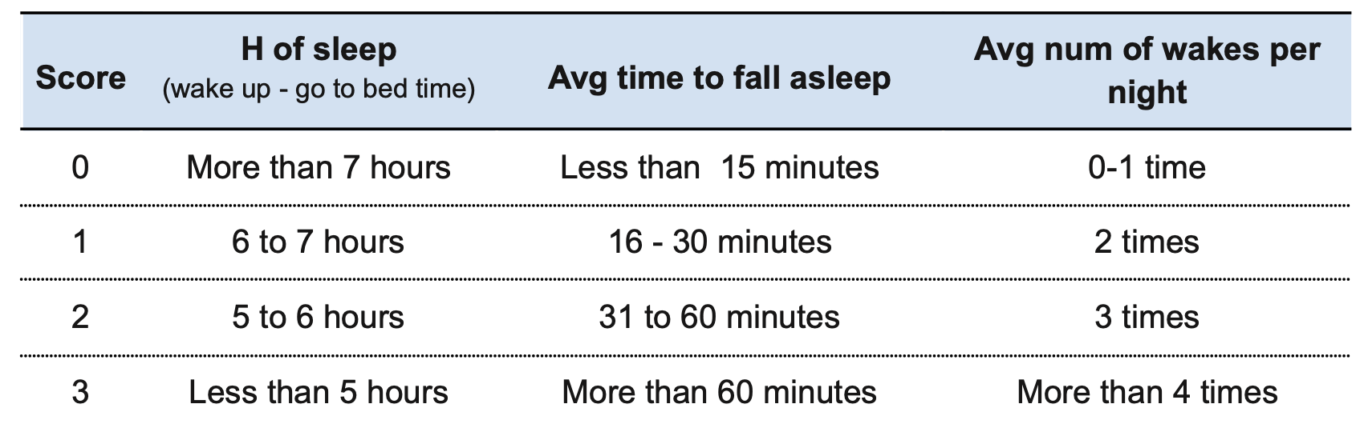

**Socialization score used in this study (from last year)**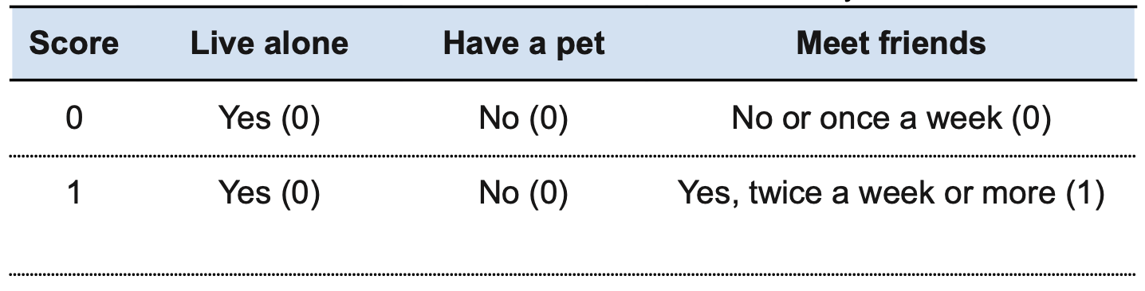

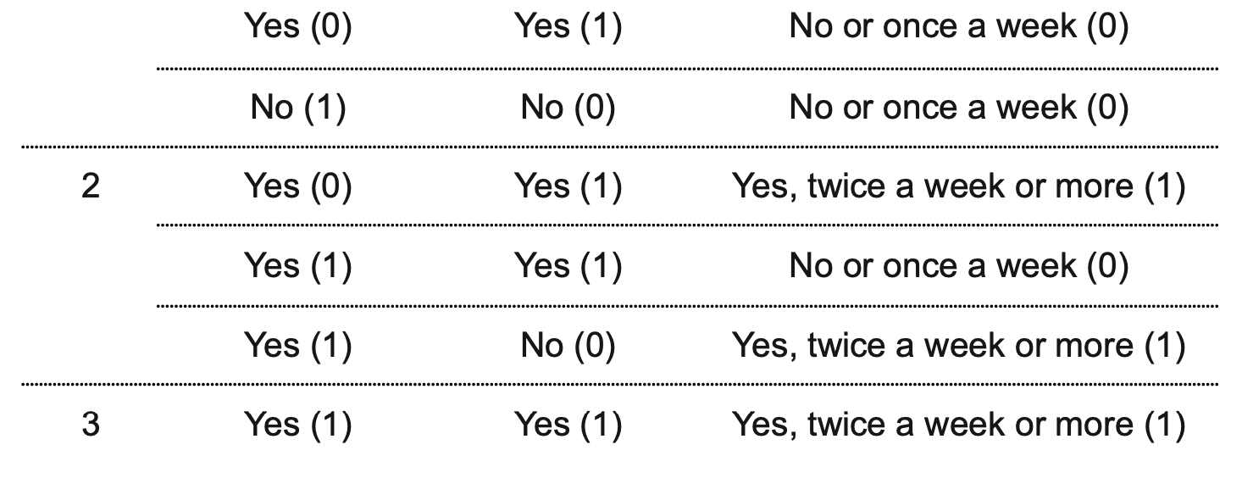

[***HERE IS THE NOTEBOOK FOR THE ANALYSIS OF THE FIRST 20 ANSWERS***](https://colab.research.google.com/drive/1pVkbO2laj3LGZ0mwan0WMU97jUq0ZOZQ?usp=sharing) ***(Just a first prototype with some comparisons with last year findings (during the lockdown))***